**SOLUTION DESIGN**

In the first block of my code I prompt the user to enter which Exchange Markets it wants to use to compare with the other four available markets. This market will be the second column in a dataframe create later, where the first column is the date. The user is prompted to enter a valid option [1-5].

The second part is where the data is downloaded for each index of the Exchange Markets considered. Namely:

1 - NYSE [New York Stock Exchange] - ^NYA

2 - NASDAQ [National Association of Securities Dealers Automated Quotations] - ^IXIC

3 - LSE [London Stock Exchange] - LSE.L

4 - NSEI [National Stock Exchange of India] - ^NSEI

5 - BM&F Bovespa [Bolsa de Valores do Estado de Sao Paulo] - ^BVSP

10 years of data is downloaded starting in 06-23-2008 to 06-22-2018.

The next block of code created a date array that will be used to create the general data frame. This array is composed by month-year as we had to analyze monthly returns. I downloaded a dataframe of daily data values to each index. These dataframes were stored in a list. In this block I create a new list of lists where I store only the last day of the month data using a proper function groupby available to dataframes. From this step I was able to calculate the monthly returns to each index and store them in a list that later was used to create a dataframe of monthly returns.

The task 04 is performed in the next block where I plot the correlation matrix.

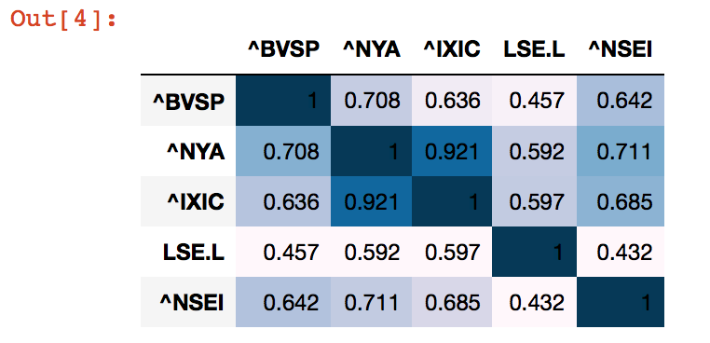

All the next blocks are used to plot different strategies to analyze the correlation between the indices. The plots were saved in pdf format available in this project folder. To save again just uncomment the plt.savefig commands. The plots can be visualized using any python IDE, however, I recommend using Jupyter Notebook to execute each part of the code that follows the order I am explaining here. The .ipynb file for jupyter is also available in this project folder.

The first plot called single lines graph is used to visualize the evolution in the returns prices over time. In this plot every index return is plotted on its own graph and allows us to verify the trends and compare one to another. The next graph plots all the lines in the same graph which is even to check whether the lines follow similar trends or not. The next two graphs are plots paired together [two by two] to verify how the returns behave. If the returns values tend to follow a linear line… then this is indication of a possible strong correlation. The next two scatter plots are plotted to compare the index chosen in the task 1 with the other indices. These plots allow us to see how two returns performed in the same say and if the variation has any correlation between the two indices. Finally, we plot a heat map of correlations. The hotter the color stronger the positive correlation, the colder indicates a negative correlation. The lighter color indicates weaker correlations.

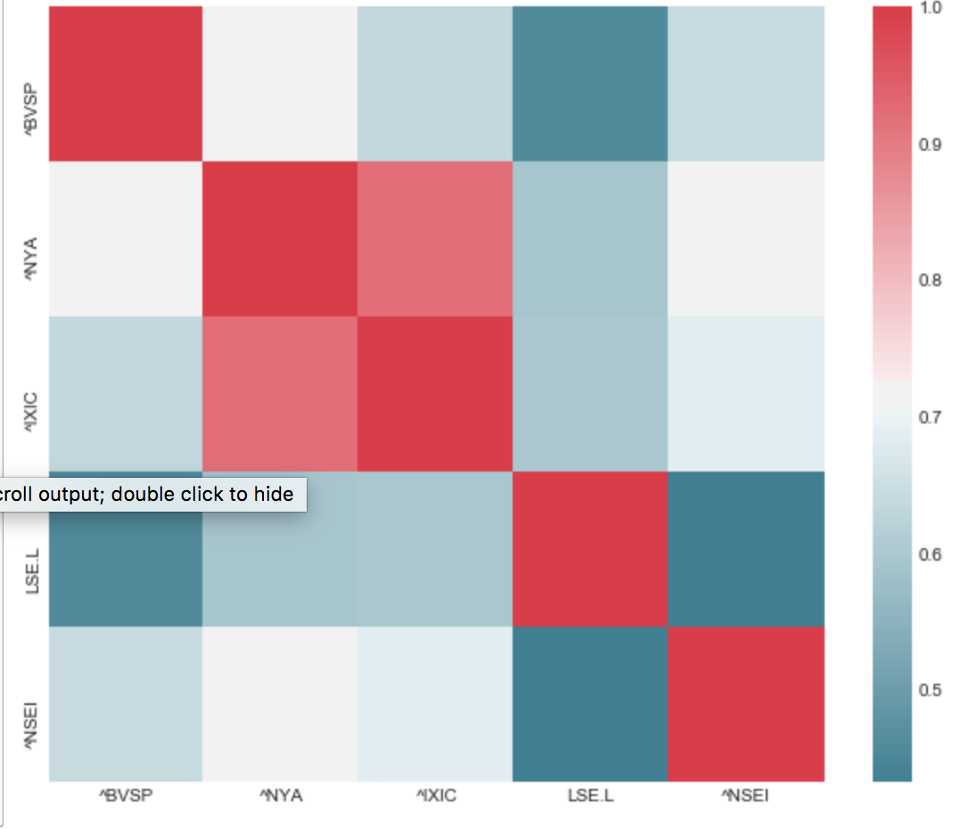

**TASK 06: ANALYSIS**

I have select two American Exchange Markets, one British, one Indian and on Brazilian. I selected the Brazilian to compare to others, but I want to analyze them altogether. Nasdaq and NYSE presented a strong correlation of 0.92. It makes sense since they both work in American markets and the fluctuations that affects USA in general will directly affect its stock markets. The fluctuation observed them, in all graphs… it is possible to see how both indices tend to follow similar behavior. Analyzing the graph where all returns are plotted over time… it is possible to see that, although not as strong as Nasdaq and NYSE, all the markets tend to follow a similar behavior. It is special true in the month of October-2008, when the global economic crisis affected stock markets all over the globe, and in our example it is showed by the significant drop in returns.

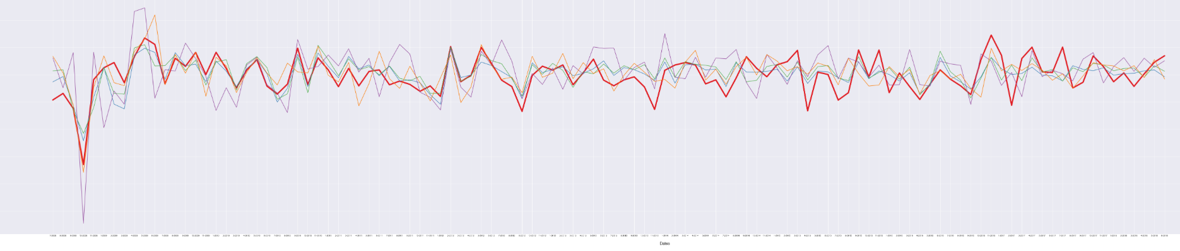

Observing the trends… they do have a similar behavior, the spikes and drops happen within max of two months of difference, indicating that a strong fluctuation in one markets can affect the others. Nevertheless, it is also observable that the American stock market seems to dictate the trends. The most undependable markets are the Indian and the British one.